
LjunggrenAudio RYO VC Sequencer:
Compact 8-step Voltage Controlled Sequencer

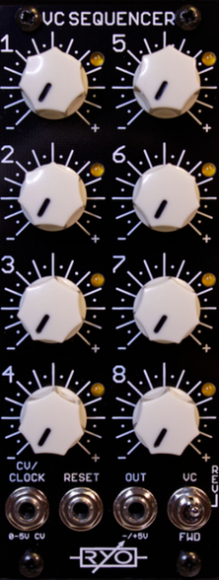

- compact 8-step sequential voltage source.
- classic forward/backward clocked operation.
- use control voltage levels scaled to each step of the sequencer to allow the waveform you feed it with to determine the running pattern.
- All analogue circuitry - no software or micro processors!
- All low latency CMOS and Opamp circuitry!
- Buffered inputs and outputs.
- slim 10HP footprint.
- compact 42mm Depth (with power cable attached).
- low power draw: 22mA +12V / 11mA -12V / 0mA +5V.
- reaches through entire audio range so also being a 3 bit hands on waveshaper!
- Schmitt triggers on all inputs.
- expanders will offer chaining of 2 VC Sequencers for 16 step operation and unlimited extra parallel channels of CV or gate/trig.

downloads
* user manual
* quickstart guide
* assembly guide
* hi-res schematic
* datasheet
* BOM

